


INTERNSHIP REPORT

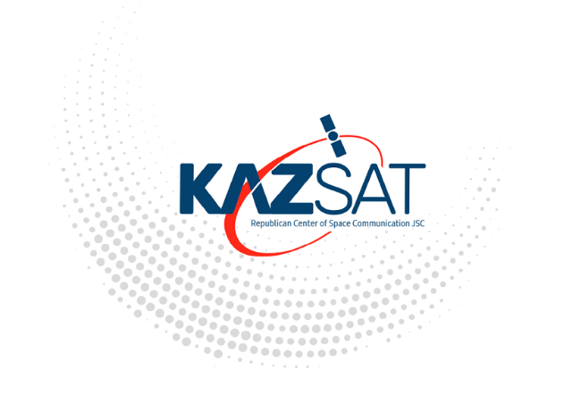

Internship Experience at Joint Stock Company "Republican Center for Space Communication"

Submitted by:
Aruana Sadubayeva
Information systems in business
09.07.2024-31.07.2024
Submitted to:
Kazakh-British Technical University

Table of Contents

Introduction 3
Description of the Company and Internship Duties 5
Company Background 5
Significant Milestones 6
Selection Process and Internship Duties 6
Reasons for Choosing JSC “RCSC” 6
Selection Process 7
Internship Duties 7
Virtual Machine Setup and Configuration 7
Technical Support and Maintenance 8
Market Research Project 9
Skills and Knowledge Gained 9
Individual Project 10
Research Question and Objectives 10
Data Collection 11
Data Analysis 12
Conclusion: 17
References: 18

Introduction
Internships serve as a critical bridge between academic theory and professional practice, providing students with an invaluable opportunity to apply their classroom knowledge in real-world environments. My internship at Joint Stock Company “Republican Center for Space Communication” (JSC “RCSC”) offered a unique and immersive experience within the space communication and satellite technology sector. Established in December 2003 by a government decree, Joint Stock Company “RCSC” is a key player in Kazakhstan’s space communication infrastructure, performing as the primary operator of the KazSat satellite system. They help with digital TV and radio broadcasting (including HD and IPTV), high-speed internet access, data transfer, and setting up corporate satellite communication networks in different configurations. Moreover,it offer transponder capacity on KazSat-2 and KazSat-3, offers infrastructure for satellite networks and telecommunication services, and monitors satellite channels in the ku-frequency range from 14 to 130 degrees east longitude.

This report provides a comprehensive overview of my internship experience at JSC “RCSC”), detailing the company’s background, my roles and responsibilities, and the insights gained from a significant individual project. The internship was strategically chosen to align with my academic background in telecommunications and my career aspirations in space technology. By working with a leading organization in this field, I was able to bridge theoretical concepts learned during my studies with practical applications in a professional setting.
Throughout the internship, I engaged in various technical and analytical tasks, including the setup and configuration of virtual machines, support in daily operations, and an extensive market research project analyzing the IT sector in Kazakhstan. This report will highlight these activities, reflecting on how they enhanced my understanding of the industry, developed my technical skills, and contributed to my professional growth. The aim is to provide a detailed account of the practical application of academic knowledge, the new skills acquired, and the overall impact of this experience on my career trajectory.
The opportunity to work at this company not only enriched my technical expertise but also offered insights into the operational dynamics of a leading space communication company. This experience has significantly influenced my career aspirations, equipping me with both the skills and confidence needed to pursue future opportunities in the telecommunications and space technology sectors.

Description of the Company and Internship Duties

Company Background
Joint Stock Company “Republican Center for Space Communication” (JSC “RCSC”) was founded in December 2003 by decree from the Government of Kazakhstan. This strategic move was aimed at bolstering Kazakhstan’s capabilities in space technology and satellite communications. Operating under the Aerospace Committee within the Ministry of Digital Development, Innovations, and Aerospace Industry, the company plays a pivotal role in the country’s space communication infrastructure.
The company is primarily responsible for operating the KazSat satellite system, which is crucial for providing comprehensive satellite communication services throughout Kazakhstan. The KazSat system, including KazSat-1, KazSat-2, and KazSat-3, supports various applications, such as digital broadcasting, broadband internet, and data transmission. These satellites are integral in delivering reliable communication services, particularly in remote and underserved regions of Kazakhstan.
JSC “RCSC” manages the transponder capacity on these satellites, which involves providing essential services such as monitoring satellite channels in the Ku-band frequency range. The company also operates a Backup Ground Control Complex, which serves as a critical component in ensuring uninterrupted satellite operations. This complex plays a key role in maintaining the performance and reliability of the satellite network.

Significant Milestones
Over the years, JSC “RCSC” has achieved several significant turning points, including:
- Successful Deployment of KazSat Satellites: The launch and operational success of KazSat-1, KazSat-2, and KazSat-3 have been major achievements, positioning Kazakhstan as a leader in satellite communication within the region.
- Expansion of Services: The company has expanded its service offerings to include broadband internet access, digital broadcasting, and corporate satellite communication networks, enhancing connectivity across Kazakhstan.
- Technological Advancements: JSC “RCSC” has invested in advanced technologies and infrastructure, including the development of the Backup Ground Control Complex, to support and enhance satellite operations.
The company's mission is centered on advancing Kazakhstan’s telecommunication capabilities through state-of-the-art space technology, contributing to the nation's digital transformation and technological progress.

Selection Process and Internship Duties

Reasons for Choosing JSC “RCSC”
The decision to undertake an internship at JSC “RCSC” was driven by my strong interest in space technology and satellite communications. The company’s prominent role in Kazakhstan’s space communication sector offered an ideal environment for applying my academic knowledge and gaining hands-on experience. The opportunity to work with a leading organization in this field aligned with my career goals and academic background in telecommunications.

Selection Process
The selection process began with applying through my university’s internship program, where I expressed my interest in space technology and telecommunications. Following my application, I was invited for an interview with JSC “RCSC” representatives. During the interview, I highlighted my enthusiasm for contributing to the company's operations and my eagerness to learn from industry experts. The interview process assessed my technical knowledge, problem-solving skills, and alignment with the company’s goals.

Internship Duties
During my internship, I was assigned a range of responsibilities that provided a comprehensive experience in space communication operations:

Virtual Machine Setup and Configuration
One of my primary tasks was to set up and configure virtual machines for various applications related to satellite communication and data analysis. This involved:
  - Installing Operating Systems: Configuring and installing operating systems on virtual machines to ensure compatibility with the company's software.
  - Software Installation: Installing essential software applications used for satellite communication, data analysis, and system monitoring.The programm name was Ubuntu.
  - Network Configuration: Setting up network settings to ensure seamless integration with the company’s existing systems and networks.
This task significantly enhanced my technical proficiency and understanding of virtual environments, providing hands-on experience with industry-standard tools and technologies.
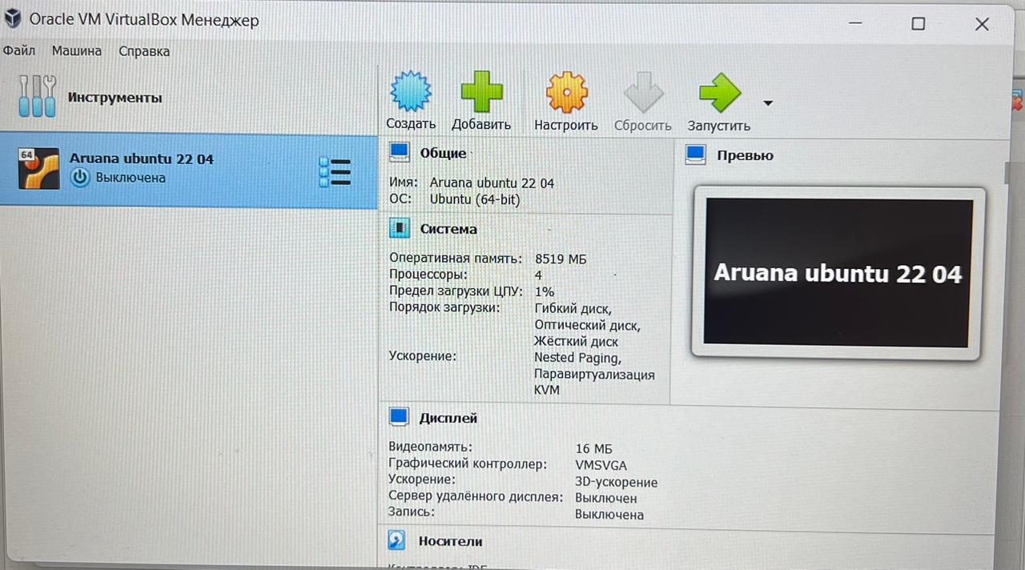

Technical Support and Maintenance
I supported my supervisor with various technical tasks, including:
  - Data Management: Assisting in the management and organization of data related to satellite operations, ensuring data accuracy and accessibility.
  - Report Generation: Preparing reports on system performance, maintenance activities, and other technical aspects. These reports were crucial for monitoring and optimizing satellite operations.
  - Troubleshooting: Providing technical support for troubleshooting issues related to satellite communication systems. This involved diagnosing and resolving problems to ensure uninterrupted service.
This role allowed me to gain practical insights into the operational aspects of space communication and develop problem-solving skills in a professional setting.

Market Research Project
A key component of my internship was conducting a comprehensive market research project within the IT sector. The project involved:
  - Data Collection: Gathering information on 100 IT companies operating in Kazakhstan, focusing on their specialization, market share, financial volume, tax obligations, and affiliated entities. Data was sourced from company websites, industry reports, and financial statements.
  - Data Analysis: Applying statistical methods to analyze the collected data. This included hypothesis testing, simple linear regression, and descriptive statistics to identify trends and relationships within the data.
  - Report Preparation: Compiling the analysis into detailed reports and presentations. The reports highlighted key findings, including market share distribution, financial performance comparisons, and specialization analysis.
This project provided valuable insights into the IT sector’s competitive landscape and the positioning of key players, enhancing my analytical skills and offering practical experience in market research.

Skills and Knowledge Gained
The internship provided numerous opportunities for skill development:
- Technical Skills: Enhanced my abilities in configuring virtual machines, managing technical systems, and performing data analysis.
- Analytical Skills: Improved my capacity to analyze market data, apply statistical methods, and interpret research findings.
- Professional Skills: Developed my problem-solving skills, report writing abilities, and understanding of industry practices.
My time at JSC "RCSC" helped me connect theoretical knowledge with practical experience, strengthening my academic understanding and preparing me for future career opportunities in telecommunications and space technology.

Individual Project
Introduction to the Project
The individual project undertaken, involved a comprehensive analysis of the IT sector in Kazakhstan. The primary objective of this project was to assess and understand the competitive landscape of IT companies within the region by analyzing various metrics such as company specialization, market share, financial performance, tax obligations, and ownership structures. This project was designed to apply theoretical knowledge from my studies in Probability and Statistics, and to gain practical insights into the industry.

Research Question and Objectives
The research question guiding this project was: "What are the key characteristics and competitive dynamics of IT companies operating in Kazakhstan?" The objectives were:
- To identify and profile major IT companies in Kazakhstan.
- To analyze market share distribution and financial performance.
- To evaluate the impact of company specialization and ownership on market positioning.
- To provide insights into the competitive landscape of the IT sector.

Data Collection
Data collection was a critical phase of the project, requiring a systematic approach to gather relevant information on 100 IT companies in Kazakhstan. The data was collected from various sources:
- Company Websites: Official websites provided information on company specialization, services, and organizational structure.
- Industry Reports: Reports from industry analysts and market research firms offered insights into market share, financial performance, and industry trends.
- Financial Statements: Annual reports and financial statements of companies were reviewed to obtain data on revenue, profitability, and investment levels.
- Public Databases: Various public databases and industry directories were utilized to gather additional information on company tax obligations and ownership structures.
The collected data included:
- Company Specialization: The primary areas of focus for each company, such as software development, IT services, or hardware manufacturing.
- Market Share: Estimates of each company's market share within the IT sector.
- Financial Performance: Key financial metrics including revenue, profitability, and growth rates.
- Tax Obligations: Information on the tax obligations of companies.
- Ownership Structure: Details on company founders, major shareholders, and affiliated entities.

Data Analysis
The data analysis phase involved applying several statistical and analytical techniques to derive meaningful insights. The key steps included:
1.Descriptive Statistics
Descriptive statistics were used to summarize and describe the key features of the collected data. This included calculating mean, median, mode, and standard deviation for various metrics, such as revenue and market share. The descriptive analysis provided an overview of the data distribution and highlighted general trends within the IT sector.
2.Hypothesis Testing
Hypothesis testing was employed to evaluate assumptions about the relationships between different variables:
  - Hypothesis Testing for Market Share: Tested hypotheses regarding the impact of company specialization on market share. For example, whether companies specializing in certain areas, like software development, had significantly higher market shares compared to those in other sectors.
  - Hypothesis Testing for Financial Performance: Evaluated whether there were significant differences in financial performance (revenue, profitability) based on company size or specialization.

3.Simple Linear Regression
Simple linear regression models were used to analyze relationships between variables and identify trends:
  - Revenue Trends: Analyzed the relationship between company size (number of employees) and revenue to identify trends and make predictions about future performance.
  - Investment and Growth: Examined the impact of investment levels on revenue growth, determining if higher investments were associated with better financial performance.
- Visual Representation
To enhance the clarity of the findings, the table was created and included:
  - Market Share Distribution Information: Displayed the percentage distribution of market share among the top IT companies.
  - Financial Performance Comparison Table: Compared revenue and profitability figures across different companies, highlighting variations and trends.
  - Specialization Analysis Chart: Illustrated the primary focus areas and services of each company, showing how specialization impacts market positioning.

Results and Interpretation
The analysis provided several key insights into the IT sector in Kazakhstan:
1.Market Share Distribution
The market share distribution analysis revealed that a few leading companies held significant shares of the market, indicating strong competitive positions. The distribution was highly concentrated, with a few dominant players controlling a large portion of the market.

2.Financial Performance Variations
The financial performance analysis showed notable differences in revenue and profitability among companies. Leading companies exhibited higher revenue and profitability, reflecting their established market presence and competitive advantage. Emerging companies, while showing potential for growth, generally had lower financial metrics.

Impact of Specialization
The hypothesis testing and regression analysis indicated that companies specializing in high-demand areas, such as software development and IT services, tended to have higher market shares and better financial performance. Specialization in niche areas was associated with competitive advantages and higher revenue growth.
1.Investment and Growth Trends
The regression analysis demonstrated that higher investment levels were positively correlated with revenue growth. Companies that invested more in research and development, technology, and infrastructure generally experienced better financial performance.

A small excerpt from my work: 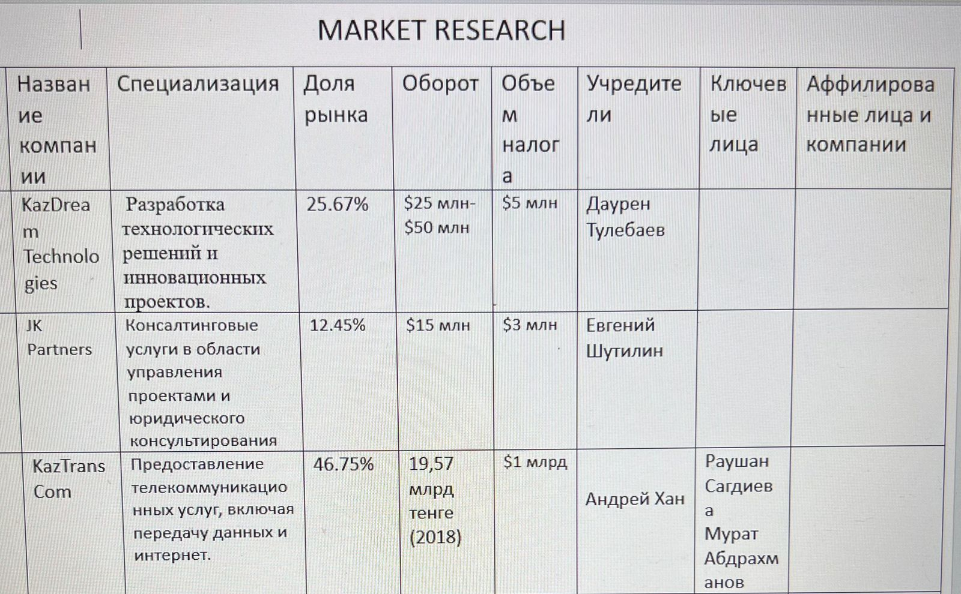

Conclusion:
My internship at JSC “Republican Center for Space Communication” was an exceptionally rewarding experience that significantly contributed to both my professional and personal development. Engaging with a leading organization in Kazakhstan’s space communication sector allowed me to enhance the gap between theoretical knowledge and practical application, reinforcing and expanding my skills in a real-world setting.
The comprehensive exposure to satellite communication technologies, coupled with hands-on experience in setting up virtual machines, managing technical systems, and conducting in-depth market research, provided me with invaluable insights into the telecommunications industry. Working on the individual project, which involved analyzing the IT sector in Kazakhstan, enabled me to apply statistical methods and data analysis techniques acquired during my studies. This project not only enhanced my analytical skills but also provided a nuanced understanding of market dynamics and competitive positioning.
Throughout the internship, I developed a deeper appreciation for the complexities of space communication and the operational intricacies of satellite systems. The practical experience gained in configuring technical setups, supporting daily operations, and conducting detailed market research has equipped me with a solid foundation for future career endeavors in telecommunications and space technology.
Overall, this internship has been an essential step in my career journey. It has not only boosted my technical expertise and analytical capabilities but also strengthened my career aspirations. The skills and knowledge acquired during this period will undoubtedly influence my future professional pursuits, providing a strong basis for continued growth and success in the field of space communication and technology.

References:
1. JSC “Republican Center for Space Communication” Official Website. (2024). Overview of Services and Operations. Retrieved from
https://www.rcsc.kz/Services/TransponderEng
2.KazSat Satellite System Documentation. (2024). Retrieved from https://space.skyrocket.de/doc_sdat/kazsat-1.htm
3. IT Services – Kazakhstan. Retrieved from
https://www.statista.com/outlook/tmo/it-services/kazakhstan
4. Financial Statements of IT Companies in Kazakhstan. (2024). Obtained from company websites and financial databases during the market research project.
5. Academic Strive.(24.06.2024). Essential Statistical Methods and Tools for Researchers.Retrieved from
https://medium.com/@academicstrivee/essential-statistical-methods-and-tools-for-researchers-b40a15724091
6.Kozhakhmetov, R., & Mukhamedzhanova, A. (2023). Innovative IT Solutions and Their Impact on the Economy of Kazakhstan. Journal of Digital Economy, 12(3), 45-62. Retrieved from Journal of Digital Economy.
7. The Astana Times. (20.03.2024). Kazakhstan’s IT Sector Sees Rapid Growth in 2024.The Astana Times. Retrieved from
https://astanatimes.com/
8. IDC. (2024). IT Market in Kazakhstan: Trends and Forecasts 2024-2028.Retrieved from https://www.statista.com/outlook/tmo/it-services/kazakhstan

